Android Programming
Practical No. 3
Understanding Android Components. Create and Android application with multiple activities. Implement the life cycle methods of each activity and observe their execution.
- Create a New Project
- Open Android Studio
- Click New Project
- Select Empty View Activity
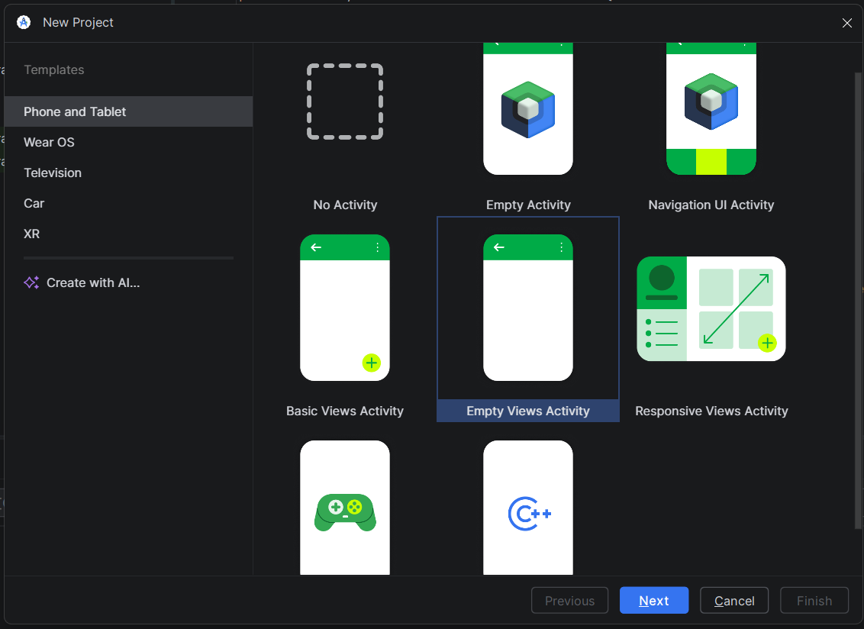
- Select Language → Java
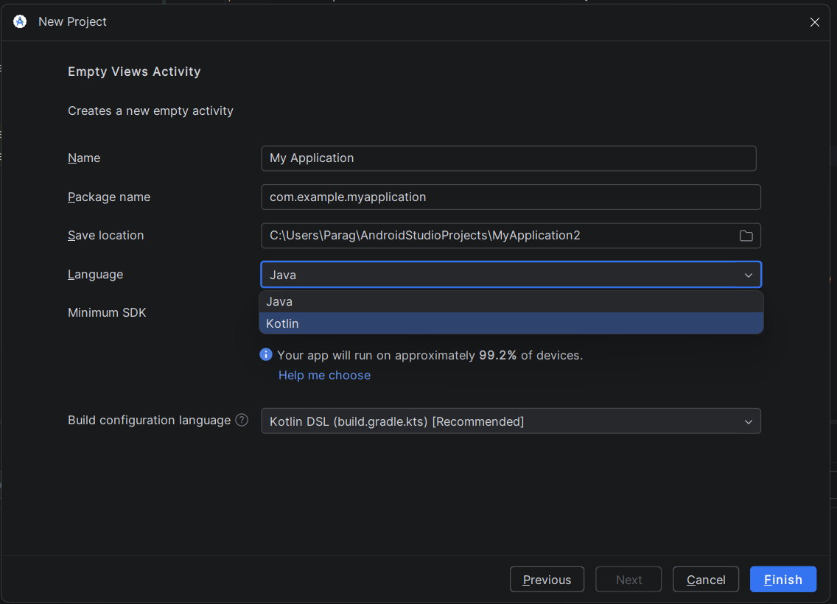
- Finish

- activity_main.xml
<Button
android:layout_width="match_parent"
android:layout_height="wrap_content"
android:id="@+id/btnNext"
android:text="Next"/>

- Add Second Activity Layout
Right click on layoutNewActivityEmpty Views Activity
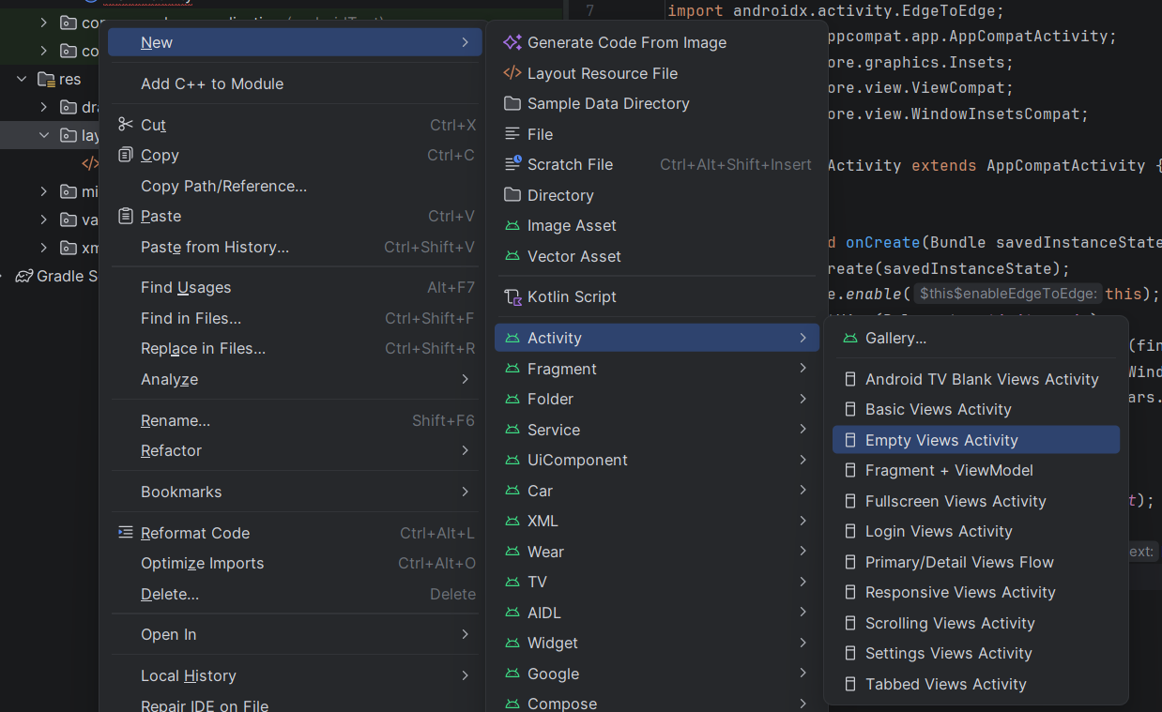
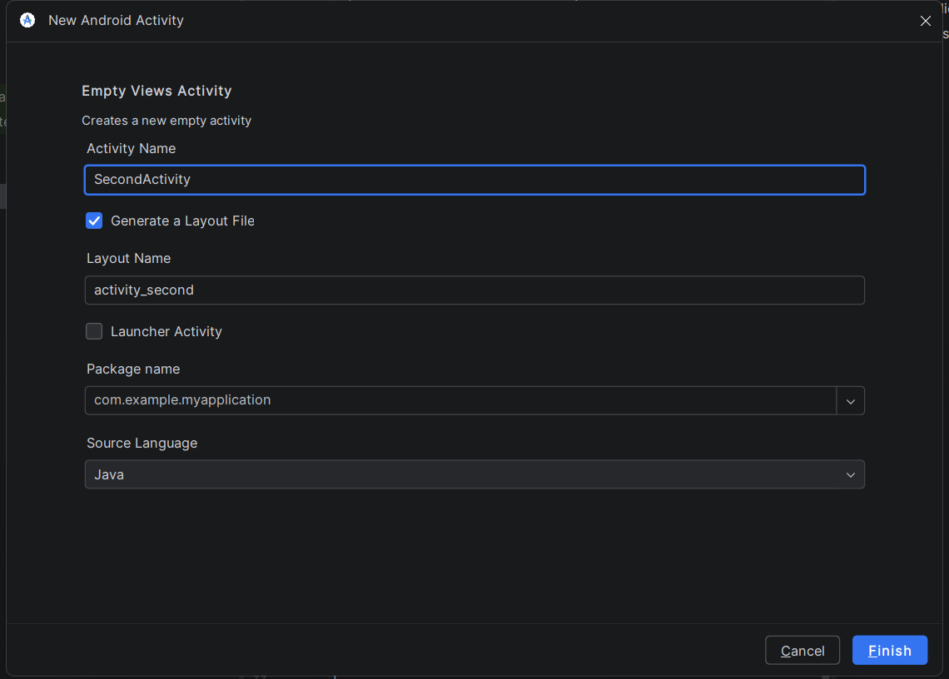

- Activity_second.xml
<EditText
android:id="@+id/etUsername"
android:layout_width="match_parent"
android:layout_height="wrap_content"
android:ems="10"
android:inputType="text"
android:hint="User Name"
tools:layout_editor_absoluteX="7dp"
tools:layout_editor_absoluteY="22dp" />

<EditText
android:id="@+id/etPassword"
android:layout_width="match_parent"
android:layout_height="wrap_content"
android:ems="10"
android:hint="Password"
android:inputType="textPassword"
tools:layout_editor_absoluteX="9dp"
tools:layout_editor_absoluteY="85dp"
app:layout_constraintTop_toBottomOf="@+id/etUsername"/>

<Button
android:id="@+id/btnLogin"
android:layout_width="match_parent"
android:layout_height="wrap_content"
android:text="Login"
tools:layout_editor_absoluteX="56dp"
tools:layout_editor_absoluteY="139dp"
app:layout_constraintTop_toBottomOf="@+id/etPassword"/>

- Add Welcome Activity Layout
Right click on layoutNewActivityEmpty Views Activity
activity_welcome.xml

<TextView
android:id="@+id/tvWelcome"
android:layout_width="match_parent"
android:layout_height="wrap_content"
android:text="TextView"
tools:layout_editor_absoluteX="123dp"
tools:layout_editor_absoluteY="83dp" />

- MainActivity.java
package com.example.myapplication;

import android.content.Intent;
import android.os.Bundle;
import android.widget.Button;

import androidx.activity.EdgeToEdge;
import androidx.appcompat.app.AppCompatActivity;
import androidx.core.graphics.Insets;
import androidx.core.view.ViewCompat;
import androidx.core.view.WindowInsetsCompat;

public class MainActivity extends AppCompatActivity {

@Override
protected void onCreate(Bundle savedInstanceState) {
super.onCreate(savedInstanceState);
EdgeToEdge.enable(this);
setContentView(R.layout.activity_main);
ViewCompat.setOnApplyWindowInsetsListener(findViewById(R.id.main), (v, insets) -> {
Insets systemBars = insets.getInsets(WindowInsetsCompat.Type.systemBars());
v.setPadding(systemBars.left, systemBars.top, systemBars.right, systemBars.bottom);
return insets;
});

Button btnNext = findViewById(R.id.btnNext);
btnNext.setOnClickListener(v -> {
Intent intent = new Intent(MainActivity.this, SecondActivity.class);
startActivity(intent);
});
}
}

- SecondActivity.java
package com.example.myapplication;

import android.content.Intent;
import android.os.Bundle;
import android.widget.Button;
import android.widget.EditText;
import android.widget.Toast;

import androidx.activity.EdgeToEdge;
import androidx.appcompat.app.AppCompatActivity;
import androidx.core.graphics.Insets;
import androidx.core.view.ViewCompat;
import androidx.core.view.WindowInsetsCompat;

public class SecondActivity extends AppCompatActivity {

@Override
protected void onCreate(Bundle savedInstanceState) {
super.onCreate(savedInstanceState);
EdgeToEdge.enable(this);
setContentView(R.layout.activity_second);
ViewCompat.setOnApplyWindowInsetsListener(findViewById(R.id.main), (v, insets) -> {
Insets systemBars = insets.getInsets(WindowInsetsCompat.Type.systemBars());
v.setPadding(systemBars.left, systemBars.top, systemBars.right, systemBars.bottom);
return insets;
});
EditText etUsername = findViewById(R.id.etUsername);
EditText etPassword = findViewById(R.id.etPassword);
Button btnLogin = findViewById(R.id.btnLogin);
btnLogin.setOnClickListener(v -> {
String username = etUsername.getText().toString();
String password = etPassword.getText().toString();
// Perform login logic here
// For example, check if the username and password are correct
if (username.isEmpty() || password.isEmpty()) {
// Show an error message if the fields are empty
Toast.makeText(SecondActivity.this, "Please enter both username and password", Toast.LENGTH_SHORT).show();
} else {
// Login successful, navigate to the next activity
Intent intent = new Intent(SecondActivity.this, WelcomeActivity.class);
intent.putExtra("username", username);
startActivity(intent);
}
});
}
}

- WelcomeActivity.java
package com.example.myapplication;

import android.os.Bundle;
import android.widget.TextView;

import androidx.activity.EdgeToEdge;
import androidx.appcompat.app.AppCompatActivity;
import androidx.core.graphics.Insets;
import androidx.core.view.ViewCompat;
import androidx.core.view.WindowInsetsCompat;

public class WelcomeActivity extends AppCompatActivity {

@Override
protected void onCreate(Bundle savedInstanceState) {
super.onCreate(savedInstanceState);
EdgeToEdge.enable(this);
setContentView(R.layout.activity_welcome);
ViewCompat.setOnApplyWindowInsetsListener(findViewById(R.id.main), (v, insets) -> {
Insets systemBars = insets.getInsets(WindowInsetsCompat.Type.systemBars());
v.setPadding(systemBars.left, systemBars.top, systemBars.right, systemBars.bottom);
return insets;
});
TextView tvWelcome = findViewById(R.id.tvWelcome);
//Receive username from the intent
String username = getIntent().getStringExtra("username");
//Display welcome message with the username
tvWelcome.setText("Welcome, " + username + "!");
}
}

Practical No. 4
Implementing Services in Android. Develop a service that runs in the background and performs a simple task. Observer the life cycle of the service and its interaction with the main application.
Android Timer Service Example
Objective
Develop a Service that runs in the background and performs a timer task. The service will count seconds and show them using Toast.

Step 1: Create Android Project
- Open Android Studio
- Click New Project
- Select Empty Views Activity
- Language: Java
- Project Name: TimerServiceApp

Step 2: Create Service Class
Right click Java Package → New → Service → TimerService
TimerService.java
package com.example.timerserviceapp;
import android.app.Service;
import android.content.Intent;
import android.os.IBinder;
import android.widget.Toast;
public class TimerService extends Service {
int seconds = 0;
boolean running = true;
@Override
public void onCreate() {
super.onCreate();
Toast.makeText(this, "Service Created", Toast.LENGTH_SHORT).show();
}
@Override
public int onStartCommand(Intent intent, int flags, int startId) {
new Thread(new Runnable() {
@Override
public void run() {
while(running)
{
try {
Thread.sleep(1000);
seconds++;
Toast.makeText(getApplicationContext(),
"Timer: " + seconds + " seconds",
Toast.LENGTH_SHORT).show();
} catch (Exception e) {
e.printStackTrace();
}
}
}
}).start();
return START_STICKY;
}
@Override
public void onDestroy() {
running = false;
Toast.makeText(this,"Service Stopped",Toast.LENGTH_SHORT).show();
super.onDestroy();
}
@Override
public IBinder onBind(Intent intent) {
return null;
}
}

Step 3: Register Service in AndroidManifest.xml
Add this inside <application>:
<service android:name=".TimerService"/>

Step 4: Create Layout
activity_main.xml
<?xml version="1.0" encoding="utf-8"?>
<LinearLayout xmlns:android="http://schemas.android.com/apk/res/android"
android:layout_width="match_parent"
android:layout_height="match_parent"
android:gravity="center"
android:orientation="vertical">
<Button
android:id="@+id/startService"
android:layout_width="wrap_content"
android:layout_height="wrap_content"
android:text="Start Timer Service"/>
<Button
android:id="@+id/stopService"
android:layout_width="wrap_content"
android:layout_height="wrap_content"
android:text="Stop Timer Service"/>
</LinearLayout>

Step 5: MainActivity.java
package com.example.timerserviceapp;
import androidx.appcompat.app.AppCompatActivity;
import android.content.Intent;
import android.os.Bundle;
import android.view.View;
import android.widget.Button;
public class MainActivity extends AppCompatActivity {
Button startService, stopService;
@Override
protected void onCreate(Bundle savedInstanceState) {
super.onCreate(savedInstanceState);
setContentView(R.layout.activity_main);
startService = findViewById(R.id.startService);
stopService = findViewById(R.id.stopService);
startService.setOnClickListener(new View.OnClickListener() {
@Override
public void onClick(View v) {
startService(new Intent(MainActivity.this, TimerService.class));
}
});
stopService.setOnClickListener(new View.OnClickListener() {
@Override
public void onClick(View v) {
stopService(new Intent(MainActivity.this, TimerService.class));
}
});
}
}

Practical No.5
Create a content provider to manage and share data between different components of your android application.
To manage and share data between different components of your Android application, you can implement a ContentProvider. A ContentProvider acts as an abstraction layer over your app’s data sources (like SQLite databases, files, or even network data) and provides a standard interface for other components or apps to query and modify that data.
Usually it uses SQLite, but it is not mandatory. You can store data in:
- Arrays
- Lists
- Files
- SharedPreferences
- In-memory data structures
Below is a simple student-level example of Content Provider without SQLite, using ArrayList (in-memory storage).
Simple Android Application Using Content Provider (Without SQLite)
1. Create a New Project
- Open Android Studio
- Click New Project
- Select Empty View Activity
- Select Language → Java
- Finish

2. Create Content Provider Class
Right click package → New → Java Class → MyProvider
package com.example.contentproviderdemo;
import android.content.ContentProvider;
import android.content.ContentValues;
import android.database.Cursor;
import android.database.MatrixCursor;
import android.net.Uri;
import java.util.ArrayList;

public class MyProvider extends ContentProvider {

ArrayList<String> list = new ArrayList<>();

@Override
public boolean onCreate() {

list.add("Ram");
list.add("Shyam");
list.add("Amit");

return true;
}

@Override
public Cursor query(Uri uri, String[] projection, String selection,
String[] selectionArgs, String sortOrder) {

MatrixCursor cursor = new MatrixCursor(new String[]{"name"});

for(String item : list){
cursor.addRow(new Object[]{item});
}

return cursor;
}

@Override
public Uri insert(Uri uri, ContentValues values) {

String name = values.getAsString("name");
list.add(name);
return uri;
}

@Override
public int delete(Uri uri, String selection, String[] selectionArgs) {
list.clear();
return 1;
}

@Override
public int update(Uri uri, ContentValues values, String selection,
String[] selectionArgs) {
return 0;
}

@Override
public String getType(Uri uri) {
return null;
}
}

3. Register Provider in AndroidManifest.xml
<provider
android:name=".MyProvider"
android:authorities="com.example.provider"
android:exported="true"/>

4. activity_main.xml Layout
<EditText
android:id="@+id/editText"
android:hint="Enter Name"
android:layout_width="match_parent"
android:layout_height="wrap_content"/>
<Button
android:id="@+id/btnInsert"
android:text="Insert"
android:layout_width="match_parent"
android:layout_height="wrap_content"/>
<Button
android:id="@+id/btnShow"
android:text="Show Data"
android:layout_width="match_parent"
android:layout_height="wrap_content"/>

5. MainActivity.java
package com.example.contentproviderdemo;

import androidx.appcompat.app.AppCompatActivity;

import android.content.ContentValues;
import android.database.Cursor;
import android.net.Uri;
import android.os.Bundle;
import android.view.View;
import android.widget.*;

public class MainActivity extends AppCompatActivity {

EditText editText;
Button btnInsert, btnShow;

Uri uri = Uri.parse("content://com.example.provider");

@Override
protected void onCreate(Bundle savedInstanceState) {
super.onCreate(savedInstanceState);
setContentView(R.layout.activity_main);

editText = findViewById(R.id.editText);
btnInsert = findViewById(R.id.btnInsert);
btnShow = findViewById(R.id.btnShow);

btnInsert.setOnClickListener(v -> {

ContentValues values = new ContentValues();
values.put("name", editText.getText().toString());

getContentResolver().insert(uri, values);

Toast.makeText(this,"Data Inserted",Toast.LENGTH_SHORT).show();
});

btnShow.setOnClickListener(v -> {

Cursor cursor = getContentResolver().query(uri,null,null,null,null);

String result="";

while(cursor.moveToNext()){
result += cursor.getString(0) + "\n";
}

Toast.makeText(this,result,Toast.LENGTH_LONG).show();
});
}
}

Practical No. 6
Implementing broadcast receivers. Design a broadcast receiver to respond to system or application-level broadcast. Test the receiver with different broadcast scenarios.
A Broadcast Receiver is an Android component that listens for broadcast messages sent by the Android system or other applications.
Example broadcasts:
- Battery low
- Network change
- Device boot completed
- Custom application broadcast
When the broadcast occurs, the receiver triggers the onReceive() method.
Types of Broadcast
- System Broadcast
- Custom Broadcast
Step 1: Create Android Project
- Open Android Studio
- Click New Project
- Select Empty Activity
- Language: Java
- Finish

Step 2: Create BroadcastReceiver Class
Right Click
app → java → package name → New → Java Class
Name it: MyReciever
package com.example.broadcastdemo;

import android.content.BroadcastReceiver;
import android.content.Context;
import android.content.Intent;
import android.widget.Toast;
public class MyReceiver extends BroadcastReceiver {
@Override
public void onReceive(Context context, Intent intent) {
Toast.makeText(context,
"Power Connected Broadcast Received",
Toast.LENGTH_LONG).show();
}
}

Step 3: Register Receiver in AndroidManifest.xml
Open AndroidManifest.xml
Add receiver inside <application> tag.
<receiver android:name=".MyReceiver">
<intent-filter>
<action android:name="android.intent.action.ACTION_POWER_CONNECTED"/>
</intent-filter>
</receiver>

Step 4: Run the Application
- Connect Android phone/emulator
- Run the app

Step 5: Test Broadcast Scenario
Scenario 1: Power Connected
Plug the charger.
Result:
Scenario 2: Power Disconnected
Modify Manifest:
<action android:name="android.intent.action.ACTION_POWER_DISCONNECTED"/>
Result:
When charger removed → Toast appears.

Practical No. 7
Designing use interfaces. Create an android application with various layouts, including linear, relative, and constraint layouts. Implement input controls such as text input, checkboxes, and radio buttons in your UI.
Types of Layouts in Android
1. Linear Layout
LinearLayout arranges elements in a single direction either vertical or horizontal.
Features
- Simple layout
- Arranges components in one line
- Uses orientation property
2. Relative Layout
RelativeLayout places UI components relative to other components or parent layout.
Features
- Position controls relative to each other
- Flexible layout design
3. Constraint Layout
ConstraintLayout is the most modern and flexible layout used in Android.
Features
- Allows complex UI design
- Reduces nested layouts
- Uses constraints (top, bottom, start, end)

1. Objective
Create an Android application that demonstrates different layouts (LinearLayout, RelativeLayout, ConstraintLayout) and uses input controls like EditText, CheckBox, and RadioButton.

2. Create New Project
- Open Android Studio
- Click New Project
- Select Empty Views Activity
- Language: Java
- Click Finish

3. Layout Design (activity_main.xml)
Open res → layout → activity_main.xml
<?xml version="1.0" encoding="utf-8"?>
<androidx.constraintlayout.widget.ConstraintLayout
xmlns:android="http://schemas.android.com/apk/res/android"
xmlns:app="http://schemas.android.com/apk/res-auto"
android:layout_width="match_parent"
android:layout_height="match_parent">
<!-- Linear Layout -->
<LinearLayout
android:id="@+id/linearLayout"
android:orientation="vertical"
android:layout_width="0dp"
android:layout_height="wrap_content"
android:padding="16dp"
app:layout_constraintTop_toTopOf="parent"
app:layout_constraintStart_toStartOf="parent"
app:layout_constraintEnd_toEndOf="parent">
<TextView
android:text="Enter Name"
android:textSize="18sp"
android:layout_width="wrap_content"
android:layout_height="wrap_content"/>
<EditText
android:id="@+id/editName"
android:hint="Your Name"
android:layout_width="match_parent"
android:layout_height="wrap_content"/>
</LinearLayout>
<!-- Relative Layout -->
<RelativeLayout
android:id="@+id/relativeLayout"
android:layout_width="0dp"
android:layout_height="wrap_content"
android:padding="16dp"
app:layout_constraintTop_toBottomOf="@id/linearLayout"
app:layout_constraintStart_toStartOf="parent"
app:layout_constraintEnd_toEndOf="parent">
<CheckBox
android:id="@+id/checkJava"
android:text="Java"
android:layout_width="wrap_content"
android:layout_height="wrap_content"/>
<CheckBox
android:id="@+id/checkAndroid"
android:text="Android"
android:layout_below="@id/checkJava"
android:layout_width="wrap_content"
android:layout_height="wrap_content"/>
</RelativeLayout>
<!-- Radio Buttons -->
<RadioGroup
android:id="@+id/radioGroup"
android:layout_width="0dp"
android:layout_height="wrap_content"
android:orientation="vertical"
android:padding="16dp"
app:layout_constraintTop_toBottomOf="@id/relativeLayout"
app:layout_constraintStart_toStartOf="parent"
app:layout_constraintEnd_toEndOf="parent">
<RadioButton
android:id="@+id/radioMale"
android:text="Male"
android:layout_width="wrap_content"
android:layout_height="wrap_content"/>
<RadioButton
android:id="@+id/radioFemale"
android:text="Female"
android:layout_width="wrap_content"
android:layout_height="wrap_content"/>
</RadioGroup>
<Button
android:id="@+id/btnSubmit"
android:text="Submit"
android:layout_width="wrap_content"
android:layout_height="wrap_content"
app:layout_constraintTop_toBottomOf="@id/radioGroup"
app:layout_constraintStart_toStartOf="parent"
app:layout_constraintEnd_toEndOf="parent"/>
<TextView
android:layout_width="match_parent"
android:layout_height="wrap_content"
android:text="Result"
android:id="@+id/tvResults"
app:layout_constraintTop_toBottomOf="@+id/btnSubmit"/>
</androidx.constraintlayout.widget.ConstraintLayout>

4. Java Code (MainActivity.java)
Open MainActivity.java
import android.os.Bundle;
import android.view.View;
import android.widget.Button;
import android.widget.CheckBox;
import android.widget.EditText;
import android.widget.RadioButton;
import android.widget.RadioGroup;
import android.widget.TextView;
import android.widget.Toast;
import androidx.activity.EdgeToEdge;
import androidx.appcompat.app.AppCompatActivity;
import androidx.core.graphics.Insets;
import androidx.core.view.ViewCompat;
import androidx.core.view.WindowInsetsCompat;
public class MainActivity extends AppCompatActivity {
EditText editName;
CheckBox checkJava, checkAndroid;
RadioGroup radioGroup;
Button btnSubmit;
TextView tvResult;
@Override
protected void onCreate(Bundle savedInstanceState) {
super.onCreate(savedInstanceState);
EdgeToEdge.enable(this);
setContentView(R.layout.activity_main);
ViewCompat.setOnApplyWindowInsetsListener(findViewById(R.id.main), (v, insets) -> {
Insets systemBars = insets.getInsets(WindowInsetsCompat.Type.systemBars());
v.setPadding(systemBars.left, systemBars.top, systemBars.right, systemBars.bottom);
return insets;
});
editName = findViewById(R.id.editName);
checkJava = findViewById(R.id.checkJava);
checkAndroid = findViewById(R.id.checkAndroid);
radioGroup = findViewById(R.id.radioGroup);
btnSubmit = findViewById(R.id.btnSubmit);
tvResult= findViewById(R.id.tvResults);
btnSubmit.setOnClickListener(new View.OnClickListener() {
@Override
public void onClick(View view) {
String name = editName.getText().toString();
String skills = "";
if(checkJava.isChecked())
skills += "Java ";
if(checkAndroid.isChecked())
skills += "Android";
int selectedId = radioGroup.getCheckedRadioButtonId();
RadioButton radioButton = findViewById(selectedId);
String gender = radioButton.getText().toString();
String result = "Name: " + name +
"\nSkills: " + skills +
"\nGender: " + gender;
tvResult.setText(result.toString());
//Toast.makeText(MainActivity.this, result, Toast.LENGTH_LONG).show();
}
});
}
}

5. Output
The application screen will include:
- Text Input → Enter Name
- CheckBoxes → Select Skills (Java / Android)
- Radio Buttons → Select Gender
- Submit Button → Displays result using TextView

Practical No. 8
Building dialogs and Pickers. Develop an android application that utilizes dialog boxes, date pickers, and time pickers. Implement functionality to handle user interactions with these UI components.
Aim
To develop an Android application that uses Alert Dialog, Date Picker, and Time Picker and handles user interaction.
1. AlertDialog Class
AlertDialog is a dialog box that displays a message to the user and asks for a response.
It usually contains buttons like Yes, No, OK, Cancel.
It is used when the application needs confirmation or decision from the user.
Example
When the user clicks Show Dialog, this dialog appears:
Do you want to continue?
[YES] [NO]
Syntax Example
AlertDialog.Builder builder = new AlertDialog.Builder(MainActivity.this);
builder.setTitle("Confirmation");
builder.setMessage("Do you want to continue?");
builder.setPositiveButton("Yes", (dialog, which) -> {
Toast.makeText(MainActivity.this,"You clicked YES",Toast.LENGTH_SHORT).show();
});
builder.setNegativeButton("No", (dialog, which) -> {
Toast.makeText(MainActivity.this,"You clicked NO",Toast.LENGTH_SHORT).show();
});
builder.show();
Important Methods
Method | Description
setTitle() | Sets the title of the dialog
setMessage() | Displays the message
setPositiveButton() | Action when user clicks positive button
setNegativeButton() | Action when user clicks negative button
show() | Displays the dialog
2. DatePickerDialog Class
DatePickerDialog is used to allow the user to select a date from a calendar interface.
It displays a calendar style UI where users choose day, month, and year.
Example
When the user clicks Select Date, a calendar opens and the user selects a date.
Example output:
Selected Date: 15/03/2026
Syntax Example
Calendar calendar = Calendar.getInstance();
int year = calendar.get(Calendar.YEAR);
int month = calendar.get(Calendar.MONTH);
int day = calendar.get(Calendar.DAY_OF_MONTH);
DatePickerDialog datePickerDialog = new DatePickerDialog(
MainActivity.this,
(view, year1, month1, dayOfMonth) -> {
txtResult.setText("Selected Date: " + dayOfMonth + "/" + (month1+1) + "/" + year1);
},
year, month, day
);
datePickerDialog.show();
Important Parameters
Parameter | Description
context | Current activity
listener | Handles date selection
year | Default year
month | Default month
day | Default day
3. TimePickerDialog Class
TimePickerDialog allows the user to select time (hour and minute).
It displays a clock interface for selecting time.
Example
When user clicks Select Time, the clock interface opens.
Example output:
Selected Time: 14:30
Syntax Example
Calendar calendar = Calendar.getInstance();
int hour = calendar.get(Calendar.HOUR_OF_DAY);
int minute = calendar.get(Calendar.MINUTE);
TimePickerDialog timePickerDialog = new TimePickerDialog(
MainActivity.this,
(view, hourOfDay, minute1) -> {
txtResult.setText("Selected Time: " + hourOfDay + ":" + minute1);
},
hour,
minute,
true
);
timePickerDialog.show();
Important Parameters
Parameter | Description
context | Current activity
listener | Handles time selection
hour | Default hour
minute | Default minute
is24HourView | True for 24-hour format

1. XML Layout (activity_main.xml)
Create UI with three buttons and one TextView.
<?xml version="1.0" encoding="utf-8"?>
<LinearLayout xmlns:android="http://schemas.android.com/apk/res/android"
android:layout_width="match_parent"
android:layout_height="match_parent"
android:orientation="vertical"
android:gravity="center"
android:padding="20dp">
<Button
android:id="@+id/btnDialog"
android:layout_width="wrap_content"
android:layout_height="wrap_content"
android:text="Show Dialog"/>
<Button
android:id="@+id/btnDate"
android:layout_width="wrap_content"
android:layout_height="wrap_content"
android:text="Select Date"
android:layout_marginTop="20dp"/>
<Button
android:id="@+id/btnTime"
android:layout_width="wrap_content"
android:layout_height="wrap_content"
android:text="Select Time"
android:layout_marginTop="20dp"/>
<TextView
android:id="@+id/txtResult"
android:layout_width="wrap_content"
android:layout_height="wrap_content"
android:text="Result will appear here"
android:textSize="18sp"
android:layout_marginTop="30dp"/>
</LinearLayout>

2. MainActivity.java
package com.example.dialogpicker;
import androidx.appcompat.app.AppCompatActivity;
import android.app.AlertDialog;
import android.app.DatePickerDialog;
import android.app.TimePickerDialog;
import android.os.Bundle;
import android.view.View;
import android.widget.Button;
import android.widget.TextView;
import android.widget.Toast;
import java.util.Calendar;
public class MainActivity extends AppCompatActivity {
Button btnDialog, btnDate, btnTime;
TextView txtResult;
@Override
protected void onCreate(Bundle savedInstanceState) {
super.onCreate(savedInstanceState);
setContentView(R.layout.activity_main);
btnDialog = findViewById(R.id.btnDialog);
btnDate = findViewById(R.id.btnDate);
btnTime = findViewById(R.id.btnTime);
txtResult = findViewById(R.id.txtResult);
// Alert Dialog
btnDialog.setOnClickListener(new View.OnClickListener() {
@Override
public void onClick(View view) {
AlertDialog.Builder builder = new AlertDialog.Builder(MainActivity.this);
builder.setTitle("Confirmation");
builder.setMessage("Do you want to continue?");
builder.setPositiveButton("Yes", (dialog, which) -> {
Toast.makeText(MainActivity.this,"You clicked YES",Toast.LENGTH_SHORT).show();
});
builder.setNegativeButton("No", (dialog, which) -> {
Toast.makeText(MainActivity.this,"You clicked NO",Toast.LENGTH_SHORT).show();
});
builder.show();
}
});
// Date Picker
btnDate.setOnClickListener(view -> {
Calendar calendar = Calendar.getInstance();
int year = calendar.get(Calendar.YEAR);
int month = calendar.get(Calendar.MONTH);
int day = calendar.get(Calendar.DAY_OF_MONTH);
DatePickerDialog datePickerDialog = new DatePickerDialog(
MainActivity.this,
(view1, year1, month1, dayOfMonth) -> {
txtResult.setText("Selected Date: " + dayOfMonth + "/" + (month1+1) + "/" + year1);
},
year, month, day
);
datePickerDialog.show();
});
// Time Picker
btnTime.setOnClickListener(view -> {
Calendar calendar = Calendar.getInstance();
int hour = calendar.get(Calendar.HOUR_OF_DAY);
int minute = calendar.get(Calendar.MINUTE);
TimePickerDialog timePickerDialog = new TimePickerDialog(
MainActivity.this,
(view12, hourOfDay, minute1) -> {
txtResult.setText("Selected Time: " + hourOfDay + ":" + minute1);
},
hour,
minute,
true
);
timePickerDialog.show();
});
}
}

Practical No. 9
Working with Intents. Create an android application that uses both implicit and explicit intents to navigate between different activities. Implement intent filters for specific actions.
Aim
To create an Android application that uses Explicit and Implicit Intents to navigate between activities and implement Intent Filters.

1. What is an Intent?
An Intent is a messaging object used to request an action from another component in Android.
Intents are mainly used for:
- Starting another activity
- Opening system applications
- Passing data between activities

2. Types of Intents
1️⃣ Explicit Intent
Explicit intent specifies the exact activity to start.
Example:
- Move from MainActivity → SecondActivity
2️⃣ Implicit Intent
Implicit intent does not specify the target activity.
Android finds a suitable application to perform the action.
Example:
- Open browser
- Open dialer
- Share text

3. Project Structure
MainActivity
SecondActivity
activity_main.xml
activity_second.xml
AndroidManifest.xml

4. activity_main.xml
<LinearLayout xmlns:android="http://schemas.android.com/apk/res/android"
android:layout_width="match_parent"
android:layout_height="match_parent"
android:orientation="vertical"
android:gravity="center">
<Button
android:id="@+id/btnExplicit"
android:layout_width="wrap_content"
android:layout_height="wrap_content"
android:text="Open Second Activity"/>
<Button
android:id="@+id/btnBrowser"
android:layout_width="wrap_content"
android:layout_height="wrap_content"
android:text="Open Website"
android:layout_marginTop="20dp"/>
<Button
android:id="@+id/btnDial"
android:layout_width="wrap_content"
android:layout_height="wrap_content"
android:text="Open Dialer"
android:layout_marginTop="20dp"/>
</LinearLayout>

5. MainActivity.java
package com.example.intentexample;
import androidx.appcompat.app.AppCompatActivity;
import android.content.Intent;
import android.net.Uri;
import android.os.Bundle;
import android.widget.Button;
public class MainActivity extends AppCompatActivity {
Button btnExplicit, btnBrowser, btnDial;
@Override
protected void onCreate(Bundle savedInstanceState) {
super.onCreate(savedInstanceState);
setContentView(R.layout.activity_main);
btnExplicit = findViewById(R.id.btnExplicit);
btnBrowser = findViewById(R.id.btnBrowser);
btnDial = findViewById(R.id.btnDial);
// Explicit Intent
btnExplicit.setOnClickListener(v -> {
Intent intent = new Intent(MainActivity.this, SecondActivity.class);
startActivity(intent);
});
// Implicit Intent - Open Website
btnBrowser.setOnClickListener(v -> {
Intent intent = new Intent(Intent.ACTION_VIEW);
intent.setData(Uri.parse("https://www.google.com"));
startActivity(intent);
});
// Implicit Intent - Open Dialer
btnDial.setOnClickListener(v -> {
Intent intent = new Intent(Intent.ACTION_DIAL);
intent.setData(Uri.parse("tel:1234567890"));
startActivity(intent);
});
}
}

6. activity_second.xml
<LinearLayout xmlns:android="http://schemas.android.com/apk/res/android"
android:layout_width="match_parent"
android:layout_height="match_parent"
android:gravity="center">
<TextView
android:layout_width="wrap_content"
android:layout_height="wrap_content"
android:text="Welcome to Second Activity"
android:textSize="22sp"/>
</LinearLayout>

7. SecondActivity.java
package com.example.intentexample;
import androidx.appcompat.app.AppCompatActivity;
import android.os.Bundle;
public class SecondActivity extends AppCompatActivity {
@Override
protected void onCreate(Bundle savedInstanceState) {
super.onCreate(savedInstanceState);
setContentView(R.layout.activity_second);
}
}

8. Intent Filter (AndroidManifest.xml)
Intent filters allow an activity to respond to specific actions.
Example: open activity when user clicks a link.
<activity android:name=".SecondActivity">
<intent-filter>
<action android:name="android.intent.action.VIEW"/>
<category android:name="android.intent.category.DEFAULT"/>
<category android:name="android.intent.category.BROWSABLE"/>
<data android:scheme="https"
android:host="www.example.com"/>
</intent-filter>
</activity>
This means:
If user opens:
https://www.example.com
Android can launch SecondActivity.

9. Output Functionality
Explicit Intent
Button click:
MainActivity → SecondActivity

Implicit Intent (Browser)
Button click:
Open Website → Browser opens google.com

Implicit Intent (Dialer)
Button click:
Dialer opens with number 1234567890

Practical No. 10
Implementing Notification. Build an android application that sends notification to the user. Customize the appearance and behaviour of the notifications.
Step 1: Create New Project
- Open Android Studio
- Click New Project
- Select Empty Views Activity
- Name: NotificationApp
- Language: Java (or Kotlin if you prefer)
- Click Finish
Step 2: Open res/layout/activity_main.xml
<Button
android:id="@+id/btnNotify"
android:layout_width="wrap_content"
android:layout_height="wrap_content"
android:text="Send Notification"
android:layout_centerInParent="true"/>
Step 3: Add Notification Code in MainActivity
import android.app.NotificationChannel;
import android.app.NotificationManager;
import android.os.Build;
import android.os.Bundle;
import android.view.View;
import android.widget.Button;

import androidx.appcompat.app.AppCompatActivity;
import androidx.core.app.NotificationCompat;

public class MainActivity extends AppCompatActivity {

Button btnNotify;
String CHANNEL_ID = "my_channel_id";

@Override
protected void onCreate(Bundle savedInstanceState) {
super.onCreate(savedInstanceState);
setContentView(R.layout.activity_main);

btnNotify = findViewById(R.id.btnNotify);

createNotificationChannel();

btnNotify.setOnClickListener(new View.OnClickListener() {
@Override
public void onClick(View v) {

NotificationCompat.Builder builder =
new NotificationCompat.Builder(MainActivity.this, CHANNEL_ID)
.setSmallIcon(android.R.drawable.ic_dialog_info)
.setContentTitle("Hello Student 🎓")
.setContentText("This is your first notification!")
.setPriority(NotificationCompat.PRIORITY_HIGH);

NotificationManager manager =
(NotificationManager) getSystemService(NOTIFICATION_SERVICE);

manager.notify(1, builder.build());
}
});
}

private void createNotificationChannel() {
if (Build.VERSION.SDK_INT >= Build.VERSION_CODES.O) {

NotificationChannel channel = new NotificationChannel(
CHANNEL_ID,
"My Channel",
NotificationManager.IMPORTANCE_HIGH
);

NotificationManager manager = getSystemService(NotificationManager.class);
manager.createNotificationChannel(channel);
}
}
}
Step 4: Customize Notification
You can customize like this:
.setContentTitle("New Message 📩")
.setContentText("You have a new notification")
.setSmallIcon(android.R.drawable.star_on)
.setAutoCancel(true)
Add Sound / Vibration:
.setDefaults(NotificationCompat.DEFAULT_ALL)
Step 5: Add this in AndroidManifest.xml
<uses-permission android:name="android.permission.POST_NOTIFICATIONS" />
Note: - If nothing is displayed when you click the “Send Notification” button, don’t worry—this is a very common issue
App Notifications Disabled (Device Setting)
👉 Sometimes phone blocks notifications.
✔ Fix:
- Go to Settings
- Apps → Your App
- Notifications → Turn ON

*Use of POST_NOTIFICATIONS permission
This permission allows your app to “Send notifications to the user”
*Why is it important?
Starting from Android 13 (API 33), Apps cannot show notifications without user permission. User must allow notification manually.
*What happens without this permission?
Notification code runs but nothing is displayed.
Practical No. 11
Introduction to SQLite database. Set up an SQLite database in your android application. Create a table and perform basic CRUD operations.
1. What is SQLite?
SQLite is a lightweight database built into Android.
- No internet needed
- Stores data locally (inside the app)
- Used for apps like contacts, notes, etc.

2. Create New Android Project
- Open Android Studio
- Click New Project
- Choose Empty Views Activity
- Name: SQLiteStudentApp
- Language: Java
- Click Finish

3. Create Database Helper Class
Right-click → New → Java Class → DatabaseHelper
import android.content.Context;
import android.database.sqlite.SQLiteDatabase;
import android.database.sqlite.SQLiteOpenHelper;
public class DatabaseHelper extends SQLiteOpenHelper {
public static final String DATABASE_NAME = "Student.db";
public static final String TABLE_NAME = "student";
public static final String COL_1 = "ID";
public static final String COL_2 = "NAME";
public static final String COL_3 = "MARKS";
public DatabaseHelper(Context context) {
super(context, DATABASE_NAME, null, 1);
}
@Override
public void onCreate(SQLiteDatabase db) {
db.execSQL("CREATE TABLE " + TABLE_NAME +
"(ID INTEGER PRIMARY KEY AUTOINCREMENT, NAME TEXT, MARKS INTEGER)");
}
@Override
public void onUpgrade(SQLiteDatabase db, int oldVersion, int newVersion) {
db.execSQL("DROP TABLE IF EXISTS " + TABLE_NAME);
onCreate(db);
}
}

Explanation:
- SQLiteOpenHelper → Helps create/manage database
- onCreate() → Runs first time → creates table
- onUpgrade() → Updates database when version changes

4. Add CRUD Methods
Add below methods inside DatabaseHelper class

Insert Data (Create)
import android.content.ContentValues;
public boolean insertData(String name, String marks) {
SQLiteDatabase db = this.getWritableDatabase();
ContentValues contentValues = new ContentValues();
contentValues.put(COL_2, name);
contentValues.put(COL_3, marks);
long result = db.insert(TABLE_NAME, null, contentValues);
return result != -1;
}
Explanation:
- ContentValues → stores data in key-value form
- insert() → inserts row into table

View Data (Read)
import android.database.Cursor;
public Cursor getAllData() {
SQLiteDatabase db = this.getWritableDatabase();
return db.rawQuery("SELECT * FROM " + TABLE_NAME, null);
}
Explanation:
- Cursor → used to read data row by row
- rawQuery() → executes SQL query

Update Data
public boolean updateData(String id, String name, String marks) {
SQLiteDatabase db = this.getWritableDatabase();
ContentValues contentValues = new ContentValues();
contentValues.put(COL_1, id);
contentValues.put(COL_2, name);
contentValues.put(COL_3, marks);
db.update(TABLE_NAME, contentValues, "ID = ?", new String[]{id});
return true;
}

Delete Data
public Integer deleteData(String id) {
SQLiteDatabase db = this.getWritableDatabase();
return db.delete(TABLE_NAME, "ID = ?", new String[]{id});
}

5. Design UI (activity_main.xml)
<LinearLayout
android:orientation="vertical"
android:padding="16dp"
xmlns:android="http://schemas.android.com/apk/res/android"
android:layout_width="match_parent"
android:layout_height="match_parent">
<EditText android:id="@+id/editName"
android:hint="Enter Name"
android:layout_width="match_parent"
android:layout_height="wrap_content"/>
<EditText android:id="@+id/editMarks"
android:hint="Enter Marks"
android:layout_width="match_parent"
android:layout_height="wrap_content"/>
<EditText android:id="@+id/editId"
android:hint="Enter ID (for Update/Delete)"
android:layout_width="match_parent"
android:layout_height="wrap_content"/>
<Button android:id="@+id/btnAdd"
android:text="Add Data"
android:layout_width="match_parent"
android:layout_height="wrap_content"/>
<Button android:id="@+id/btnView"
android:text="View Data"
android:layout_width="match_parent"
android:layout_height="wrap_content"/>
<Button android:id="@+id/btnUpdate"
android:text="Update Data"
android:layout_width="match_parent"
android:layout_height="wrap_content"/>
<Button android:id="@+id/btnDelete"
android:text="Delete Data"
android:layout_width="match_parent"
android:layout_height="wrap_content"/>
</LinearLayout>

6. MainActivity Code
import android.database.Cursor;
import android.os.Bundle;
import android.view.View;
import android.widget.*;
import androidx.appcompat.app.AppCompatActivity;
public class MainActivity extends AppCompatActivity {
DatabaseHelper myDb;
EditText editName, editMarks, editId;
Button btnAdd, btnView, btnUpdate, btnDelete;
@Override
protected void onCreate(Bundle savedInstanceState) {
super.onCreate(savedInstanceState);
setContentView(R.layout.activity_main);
myDb = new DatabaseHelper(this);
editName = findViewById(R.id.editName);
editMarks = findViewById(R.id.editMarks);
editId = findViewById(R.id.editId);
btnAdd = findViewById(R.id.btnAdd);
btnView = findViewById(R.id.btnView);
btnUpdate = findViewById(R.id.btnUpdate);
btnDelete = findViewById(R.id.btnDelete);
// Add Data
btnAdd.setOnClickListener(v -> {
boolean isInserted = myDb.insertData(
editName.getText().toString(),
editMarks.getText().toString()
);
Toast.makeText(this,
isInserted ? "Data Inserted" : "Failed",
Toast.LENGTH_SHORT).show();
});
// View Data
btnView.setOnClickListener(v -> {
Cursor res = myDb.getAllData();
if (res.getCount() == 0) {
showMessage("Error", "No Data Found");
return;
}
StringBuilder buffer = new StringBuilder();
while (res.moveToNext()) {
buffer.append("ID: ").append(res.getString(0)).append("\n");
buffer.append("Name: ").append(res.getString(1)).append("\n");
buffer.append("Marks: ").append(res.getString(2)).append("\n\n");
}
showMessage("Data", buffer.toString());
});
// Update
btnUpdate.setOnClickListener(v -> {
boolean isUpdated = myDb.updateData(
editId.getText().toString(),
editName.getText().toString(),
editMarks.getText().toString()
);
Toast.makeText(this,
isUpdated ? "Updated" : "Failed",
Toast.LENGTH_SHORT).show();
});
// Delete
btnDelete.setOnClickListener(v -> {
int deletedRows = myDb.deleteData(editId.getText().toString());
Toast.makeText(this,
deletedRows > 0 ? "Deleted" : "Not Found",
Toast.LENGTH_SHORT).show();
});
}
public void showMessage(String title, String message) {
new android.app.AlertDialog.Builder(this)
.setTitle(title)
.setMessage(message)
.show();
}
}

Practical No. 12
Connecting application with database. Establish a connection between your android application and the SQLite database. Test the connection by inserting and retrieving data.
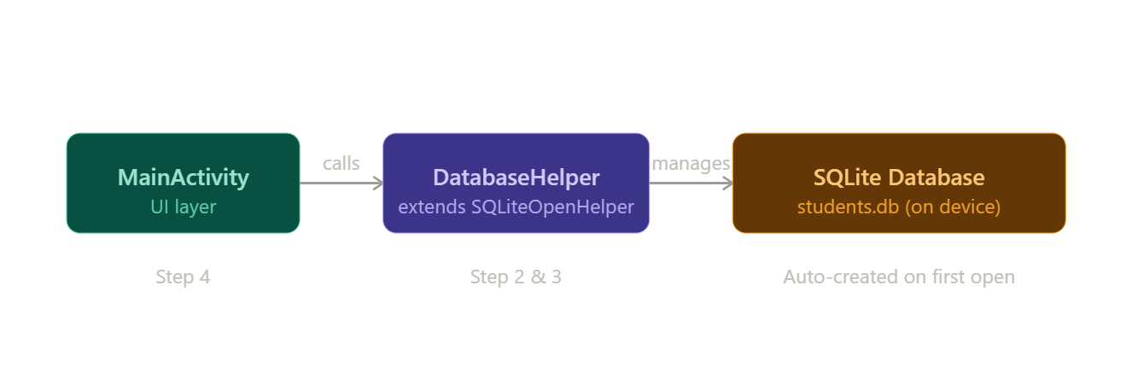
Step 1: Create Android Project
- Open Android Studio
- Click New Project
- Select Empty Views Activity
- Choose language: Java
- Finish setup
Step 2: Understand SQLite in Android
- SQLite is inbuilt in Android
- No need to install database separately
- Data is stored locally in the device
Step 3: Create Database Helper Class
- Create a class:
👉 DBHelper.java
import android.content.Context;
import android.database.sqlite.SQLiteDatabase;
import android.database.sqlite.SQLiteOpenHelper;

public class DBHelper extends SQLiteOpenHelper {

public static final String DB_NAME = "StudentDB";
public static final int DB_VERSION = 1;

public DBHelper(Context context) {
super(context, DB_NAME, null, DB_VERSION);
}

@Override
public void onCreate(SQLiteDatabase db) {
String query = "CREATE TABLE students (id INTEGER PRIMARY KEY AUTOINCREMENT, name TEXT)";
db.execSQL(query);
}

@Override
public void onUpgrade(SQLiteDatabase db, int oldVersion, int newVersion) {
db.execSQL("DROP TABLE IF EXISTS students");
onCreate(db);
}
}
This creates database + table
Step 4: Add Insert Method
import android.content.ContentValues;
import android.database.sqlite.SQLiteDatabase;

public boolean insertData(String name) {
SQLiteDatabase db = this.getWritableDatabase();
ContentValues values = new ContentValues();
values.put("name", name);

long result = db.insert("students", null, values);
return result != -1;
}
Step 5: Add Retrieve Method
import android.database.Cursor;

public Cursor getData() {
SQLiteDatabase db = this.getReadableDatabase();
return db.rawQuery("SELECT * FROM students", null);
}
Step 6: Design UI (activity_main.xml)
<LinearLayout
android:orientation="vertical"
android:padding="16dp"
xmlns:android="http://schemas.android.com/apk/res/android"
android:layout_width="match_parent"
android:layout_height="match_parent">

<EditText
android:id="@+id/editName"
android:hint="Enter Name"
android:layout_width="match_parent"
android:layout_height="wrap_content"/>

<Button
android:id="@+id/btnInsert"
android:text="Insert"
android:layout_width="match_parent"
android:layout_height="wrap_content"/>

<Button
android:id="@+id/btnView"
android:text="View Data"
android:layout_width="match_parent"
android:layout_height="wrap_content"/>
</LinearLayout>
Step 7: Connect UI with Database (MainActivity.java)
import android.database.Cursor;
import android.os.Bundle;
import android.view.View;
import android.widget.*;

import androidx.appcompat.app.AppCompatActivity;

public class MainActivity extends AppCompatActivity {

DBHelper db;
EditText editName;
Button btnInsert, btnView;

@Override
protected void onCreate(Bundle savedInstanceState) {
super.onCreate(savedInstanceState);
setContentView(R.layout.activity_main);

db = new DBHelper(this);

editName = findViewById(R.id.editName);
btnInsert = findViewById(R.id.btnInsert);
btnView = findViewById(R.id.btnView);

// Insert Data
btnInsert.setOnClickListener(v -> {
String name = editName.getText().toString();

boolean isInserted = db.insertData(name);
if (isInserted)
Toast.makeText(this, "Data Inserted", Toast.LENGTH_SHORT).show();
else
Toast.makeText(this, "Error", Toast.LENGTH_SHORT).show();
});

// View Data
btnView.setOnClickListener(v -> {
Cursor cursor = db.getData();

if (cursor.getCount() == 0) {
Toast.makeText(this, "No Data Found", Toast.LENGTH_SHORT).show();
return;
}

StringBuilder buffer = new StringBuilder();
while (cursor.moveToNext()) {
buffer.append("ID: " + cursor.getInt(0) + "\n");
buffer.append("Name: " + cursor.getString(1) + "\n\n");
}

Toast.makeText(this, buffer.toString(), Toast.LENGTH_LONG).show();
});c
}
}

